ZH,
REPORT OF JOINT INVESTIGATION VISIT BY NOSDRA, EROTON E&P, RIVERS STATE MINISTRY OF ENVIRONMENT AND MBIAMA COMMUNITY REPRESENTATIVES AT CAWTHORNE CHANNEL 2 WELL W29T 4’’ FLOW LINE @ MBIAMA SETTLEMENT IN DEGEMA L.G.A OF RIVERS STATE.
INTRODUCTION
Acting on your directives on the EROTON E&P request, a Joint Investigation Visit (JIV) was conducted at the Cawthorne Channel 2; Well W29T 4’’ Flow Line at Mbiama Settlement in Degema L.G. Area in Rivers State on the 12th of June, 2017 at about 11:30Hrs. The investigation was completed successfully on the same day. This report provides details.
INCIDENT PARTICULARS: 2017_ EEP_CC000031
FACILITY AFFECTED: CAWTHORNE CHANNEL 2; WELL W29T 4’’ FLOW LINE @ MBIAMA SETTLEMENT-DEGEMA L.G.AREA IN RIVERS STATE.
DATE OF SPILL: 10/06/2017
DATE OF INSPECTION: 12/06/2017
CAUSE OF SPILL: CORROSION (External Corrosion see Fig.1a & b)
QUANTITY OF CRUDE OIL SPILLED: 7.72bbls (Approximately 8.0bbls)
SPILL POINT COORDINATES: N 04^{O} 33’ 14.07’’
E 007^{O} 00’ 20.05”
NATURE OF IMPACT: Light
INVESTIGATION TEAM:
- Koms Abam NOSDRA
- Ibulu Kalada EROTON E&P OPERATIONS
- Felix Uzoanya EROTON E&P OSRT
- Ofonime Thompson EROTON E&P HSE
- Amanze Cyril N. EROTON E&P
- Abia Ntiense EROTON E&P MEDIA
- Igbulu GP Ijeije RIVERS STATE MINISTRY OF ENVIRONMENT
- Tonye Wokoma HOST COMMUNITY
OBSERVATIONS:
- On arrival at the Spill Area by the Joint Investigation Team, it was observed that a Cluster of Flow Lines from Well W29T conveying Crude Oil to The Gas Plant (See Fig. 2b) was found on top of the Alluvial Deposits, showing visible signs of External Corrosion. (See Fig. 1a & b).
- The Corroded 4’’ Flow Line failed and Crude Oil was discharged to the Swamp and Water Body. The Spill Point occurred at 7 O’clock position (See Fig. 1a and Fig. 3a & b)
- The Spill Occurred within EROTON E&P Right of Way – ROW; though some of the Crude Oil may have impacted the Vegetation and Water Body, since it is a Tidal Environment. (See Fig. 2a & b).
- The nearest built-up area; Mbiama Settlement and the Jetty are about 300M from the Spill Point.
- The Impact covered a Total Area of 10,600 M² with a Volume of approximately 8.0 Barrels of Crude Oil lost to the Environment (Swamp and Water Body). (See Fig. 3a & b).
IMPACTED AREA COORDINATES:
- N 04^{O} 33’ 13.09’’ 2. N 04^{O} 33’ 14.25’’ 3. N 04^{O} 33’ 13.03’’
E 007^{O} 00’ 20.03” E 007^{O} 00’ 21.97” E 007^{O} 00’ 21.43”
4. N 04^{O} 33’ 12.47’’ 5. N 04^{O} 33’ 11.87’’ 6. N 04^{O} 33’ 11.37’’
E 007^{O} 00’ 20.08” E 007^{O} 00’ 19.59” E 007^{O} 00’ 16.04’’
7. N 04^{O} 33’ 12.61’’ 8. N 04^{O} 33’ 13.28’’ 9. N 04^{O} 33’ 13.96’’
E 007^{O} 00’ 19.43” E 007^{O} 00’ 19.77” E 007^{O} 00’ 19.39”
10. N 04^{O} 33’ 13.59’’ 11. N 04^{O} 33’ 14.91’’ 12. N 04^{O} 33’ 16.38’’
E 007^{O} 00’ 15.41” E 007^{O} 00’ 20.27” E 007^{O} 00’ 18.72”
13. N 04^{O} 33’ 15.46’’
E 007^{O} 00’ 21.49”

RECOMMENDATIONS
- Repair work (Sectional Replacement) should be carried out and the area cleaned up.
CONCLUSION
The JIV was successful. This report is subject to your steer and further directives.
Koms Abam
SES

_____________________________
14th June, 2017
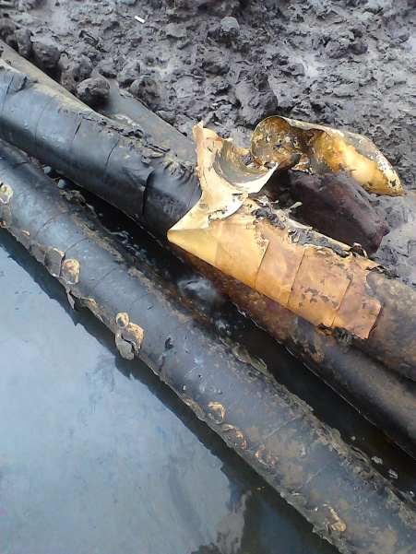 ` 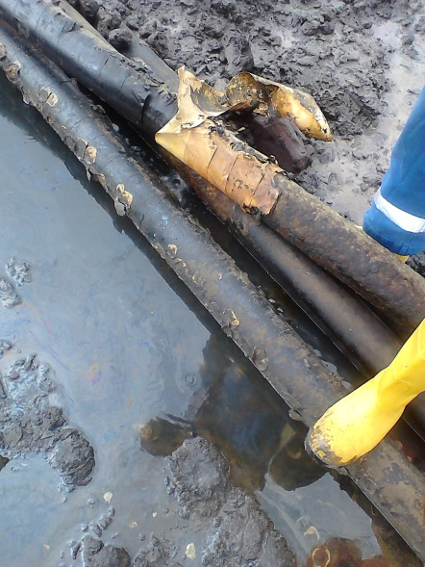
Fig. 1a Externally Corroded Flow Line Fig.1b Leak Point @ 7 O’clock Position
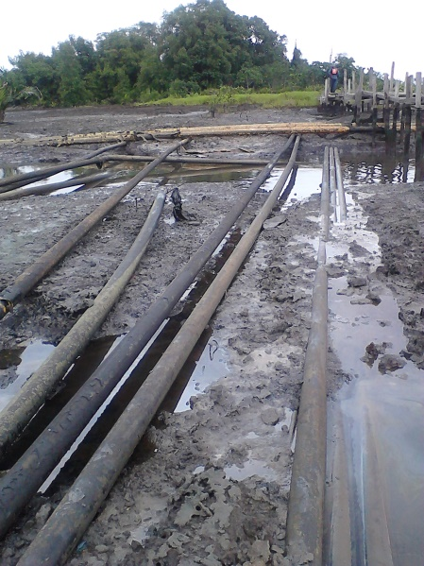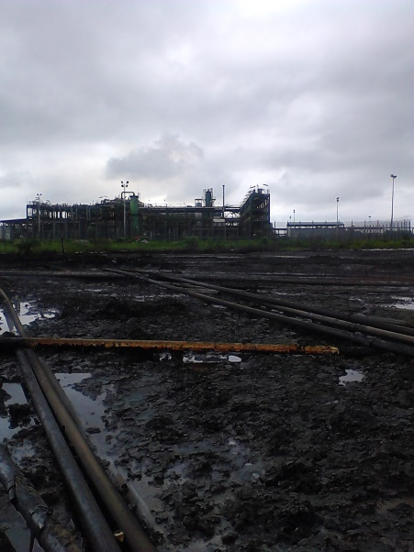
Fig. 2a Cluster of 4’’ Flow Lines from W29T Fig. 2b 4’’ Flow Lines leading to Gas Plant
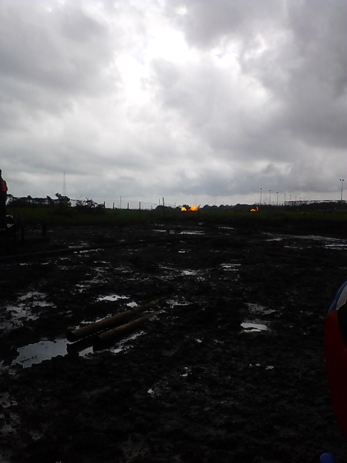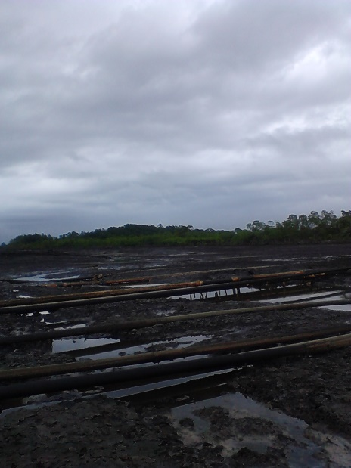
Fig. 3a Swamp Impacted Fig. 3b Adjourning Environment Impacted

